Chairperson Form
Please remember to send information in a timely way. Communication must be coordinated. Those folks approving/updating/changing information need enough time to make the updates!!

Name(s) of Chairperson(s): _______________________________________________________
Cell Phone(s) of Chairperson(s): ___________________________________________________
Email(s) of Chairperson(s): _______________________________________________________
Name of Event/Fundraiser: _______________________________________________________

Communication Needs for Event/Fundraiser (if checked, please complete section indicated):
☐ Flyer – Flyers must be approved before distribution. (Section A)
☐ Event Page – will need to add/update respective page on website (Section B)
☐ Online Store – will be available to be purchased through Shop SPS (Section C)
☐ Calendar – will be added to online calendar (on home page of school website) (Section D)
☐ Homeroom Parent Weekly Email – will be included in weekly email to families (Section D)
☐ Facebook – will be posted on School’s Facebook page (Section D)
☐ Church Bulletin – will be included in the Sunday bulletin (Section D)
***Items appearing in the Church Bulletin must be submitted 2 (two) weeks prior to when it should be in Bulletin due to the printing schedule
☐ Volunteers – will require assistance from adults and/or students (Section E)

Section A – Flyers
If the event/fundraiser requires flyer(s) please send to Sarah Fowler alassetiwele@yahoo.com for edits at least 2 weeks prior and then to Lisa Caldwell clutterranch@comcast.net and Sister Geri gmarr@spsangelway.org for final approval.
Use checklist below to track ALL flyer approvals.
☐ Flyer sent for edits
☐ Flyer sent for approval
☐ Flyer ready for distribution

Section B - Event Page Update
Before any flyer or announcement goes out about your fundraiser/event the corresponding page on the school website needs to be up-to-date so the communication is consistent. Please visit the page and provide updates/changes to Emily Marino at emtonymarino@verizon.net at least 2 weeks prior to any communication going about your event/fundraiser.
These pages are located at: www.spsangelway.org > PTG > Event or Fundraiser.
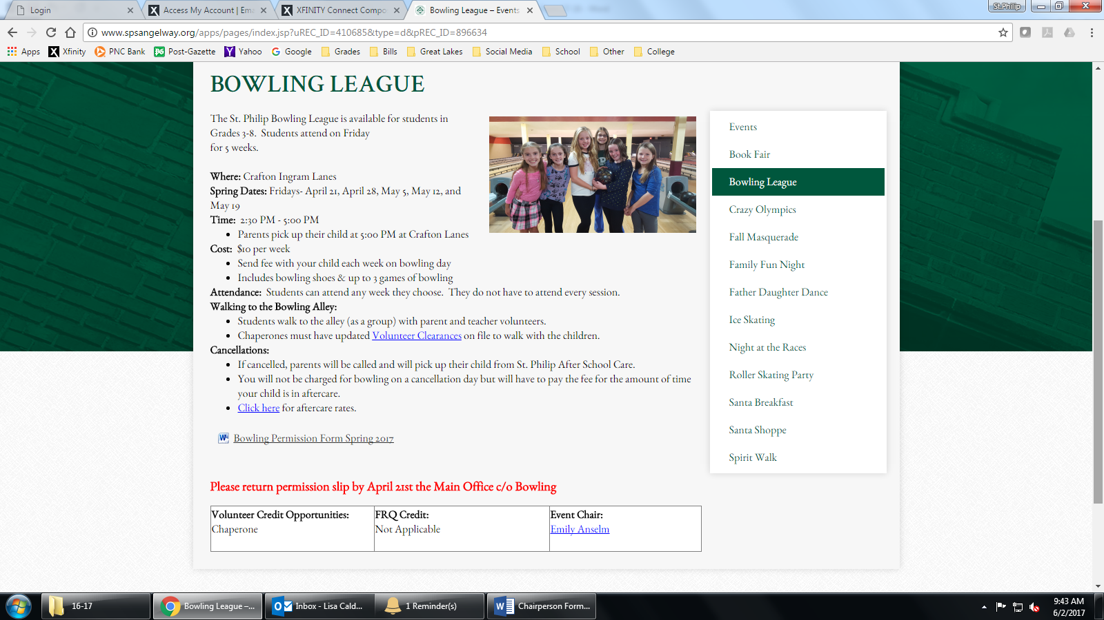
When emailing updates use this checklist to assure everything is included.
☐ Date(s) of event/fundraiser (start and end of ordering, date of event, date of pickup, or any other relevant dates)
☐ Time and Location (where is pickup or event and times)
☐ Costs and FRQ (cost of tickets, items, any FRQ information)
☐ Volunteer opportunity (yes or no; details if yes)
☐ Contact info for chair(s) (email and phone number)
☐ Any other relevant details
Section C – Online Store Items
If your event or fundraiser is selling through www.ShopSPS.org, before any flyer/announcement goes out the items need to be in the online store so communication is consistent. Please use the example and table below to send information to Tyler Dewhirst at PTGtreas@gmail.com at least 2 weeks prior to any communication going about your event/fundraiser.
Date to appear in store: _________________________________________________________
Date to be removed from store: ___________________________________________________
Example of how to complete information for online store:
Item | Type | Price | Sizes
Ticket | Adult | $7.00
Ticket | Child | $5.00
Shirt | Blue, Red, Green | $10.00 | S, M, L, XL
Shirt | Blue, Red, Green | $12.00 | XXL
Flowers | Red Begonias | $7.50 | Half Flat
Flowers | Red Begonias | $13.00 | Full Flat

Information for online store:
Item | Type | Price | Sizes

Include Student Name & Homeroom (for FRQ purposes)? ☐ Yes ☐ No
Include Name to Reserve Tickets Under (for attendance list purposes)? ☐ Yes ☐ No
Section D – Calendar / HR Parent / Facebook / Church Bulletin
If your event/fundraiser requires additional venues of communication please check what’s needed below and provide relevant information to Lisa Caldwell at clutterranch@comcast.net at least 2 weeks prior to any communication going about your event/fundraiser.
☐ School website calendar (order due date, event date, etc): ___________________________
☐ HR Parent Weekly Email Date(s) should appear: ___________________________________
☐ Facebook Date(s) should appear: _______________________________________________
☐ Bulletin Date(s) should appear: _________________________________________________
***Items appearing in the Church Bulletin must be submitted 2 (two) weeks prior to when it should be in Bulletin due to the printing schedule
Write-up should read:
______________________________________________________________________________
______________________________________________________________________________
______________________________________________________________________________
______________________________________________________________________________
______________________________________________________________________________
______________________________________________________________________________
______________________________________________________________________________
______________________________________________________________________________
______________________________________________________________________________
______________________________________________________________________________
______________________________________________________________________________
Section E – Volunteers
☐ Adult volunteers needed
***Also include this information in sections B and D above
Task | Hours | # Needed

☐ Middle school volunteers needed
It is assumed service hours will be given when middle school volunteers help with events/fundraisers. The volunteer form to be completed by the chairperson(s) and given to student is located on the school website. Click on Current Families and scroll down to Middle School Service Hours Form.
If middle school volunteers are needed, email the following information to Emily Anselm at seanselm6@gmail.com at least 2 weeks prior to when volunteers are needed and she will send it to the middle school homeroom parents to send to their classrooms:
Number of volunteers needed: _________________________________
Date, time and place: ________________________________________
Task: ______________________________________________________
Other relevant info: __________________________________________
Who to contact if questions: ____________________________________

Any questions or comments about this form can be emailed to Lisa Caldwell clutterranch@comcast.net

